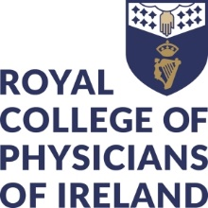


Application Form for Recognition of Non-Accredited Activities as Equivalent to Accredited Continuing Education (CE).

This form is for individual doctors seeking recognition of an activity that has not been formally accredited, as equivalent to Accredited Continuing Education (CE).

Personal Information:
Name:
Irish Medical Council Registration Number:

Activity Information:
Title of Education Activity:
Date and Location of Activity:
Activity Organised by:
Number of Hours of Educational Activity:
State the Importance of the learning Activity to the Attending Doctor
Credentials & Expertise of the Organising Body:
Teaching Methods Used:
How is the Content Relevant to Your Scope of Practice?
Provide a Rationale for why this Activity Cannot be Classified under Work-Based Learning

